University Of Engineering and Technology, Lahore
Computer Engineering Department

Course Name: Programming Fundamentals | Course Code: CMPE-112L
Assignment Type: Lab tasks | Dated: 18 May 2026
Semester: First | Session: 2026 Spring
Lab/Project/Assignment #: 1 | CLOs to be covered: CLO 2
Lab Title: Recursion | Teacher Name: Hafiz Muhammad Mubashar
Lab Evaluation:

CLO2 | Apply appropriate programming techniques to create executable programs to solve well defined problems
CLO2 | Level1 | Level2 | Level3 | Level4 | Level5 | Level6
(5)
Total |  |  |  |  |  | /5
Rubrics for Current Lab Evaluation
Scale | Marks | Level | Rubric
Excellent | 5 | L1 | Submitted all lab tasks, BONUS task, have good understanding.
Very Good | 4 | L2 | Submitted the lab tasks but have good understanding
Good | 3 | L3 | Submitted the lab tasks but have weak understanding.
Basic | 2 | L4 | Submitted the lab tasks but have no understanding.
Barely Acceptable | 1 | L5 | Submitted only one lab task.
Not Acceptable | 0 | L6 | Did not attempt
Week 10 LAB
Recursion
Lab Goals/Objectives:
• To understand the core mechanism of recursion (functions that call themselves) in Python.
• To identify and implement the two essential components of a recursive function: the base case and the recursive step.
• To apply recursive logic to classic algorithmic problems, including countdowns, factorials, and sequence generation.
Equipment Required:

* Computer/Laptop
* Python 3.14
* VS Code or pycharm

Theory:
Recursion is a programming technique where a function solves a problem by breaking it down into smaller sub-problems of the same type, calling itself to solve them.

Lab Work:

Task 1: Recursive Countdown (Direct State Reduction)
def show(i):
if (i==0):
return
print(i)
show(i-1)
Result:

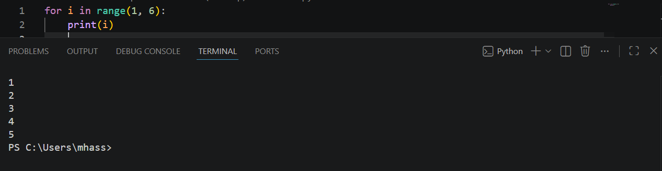

Task 2: Factorial Computation (Accumulative Call Stack Stack).
def show(n):
if n==0 or n==1:
return 1
else:
return n*show(n-1)

Result:

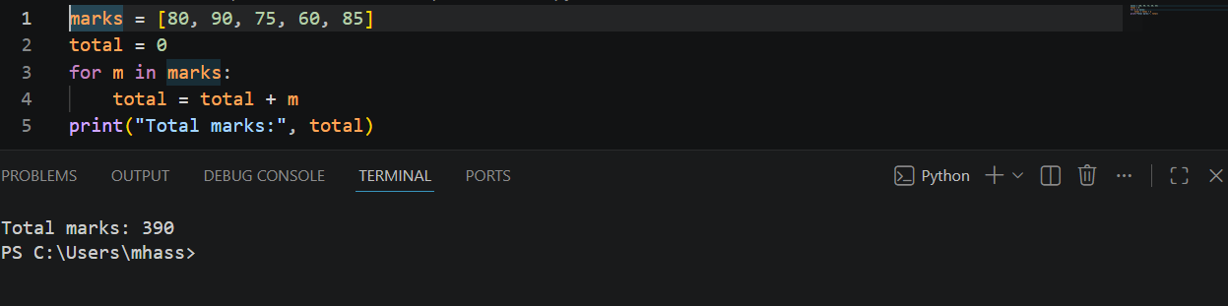

Task 3: The Fibonacci Sequence (Multiple Branches Tree Recursion).
def fibonacci_series(n):
if n <= 0:
return "Input should be a positive integer."
elif n == 1:
return 0
elif n == 2:
return 1
else:
return fibonacci_series(n-1) + fibonacci_series(n-2)
Result:
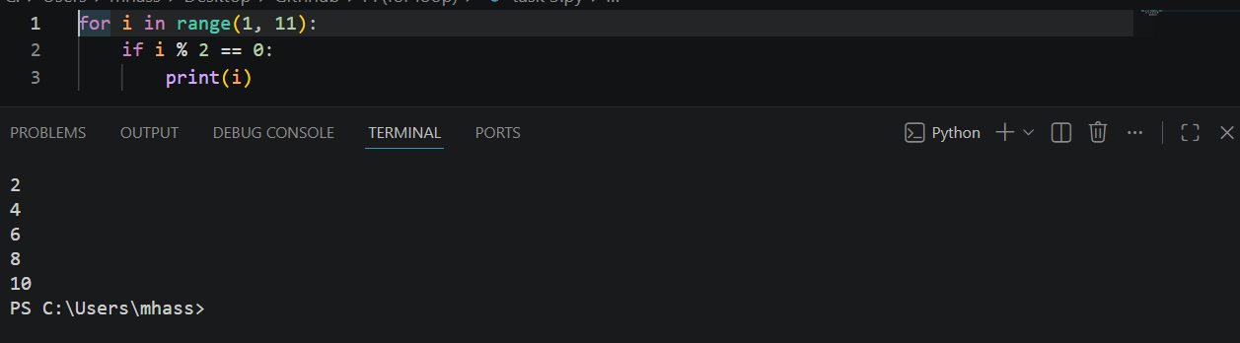

Conclusions:
This lab successfully demonstrates the implementation of recursive structures in Python. We explored how explicit base cases prevent stack overflows, how linear recursion can calculate sequential products like factorials, and how multiple branching recursion evaluates complex sequence dependencies like the Fibonacci series.

